Instructions for using JooMag, online magazine tool
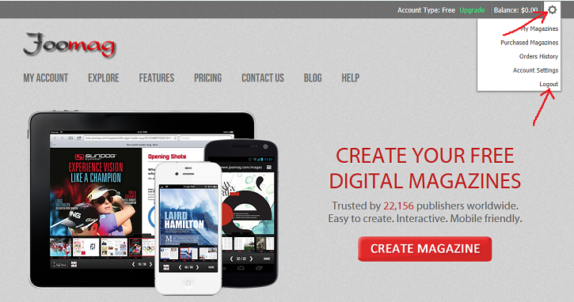
- Go to “http://www.joomag.com”
- Login to your assigned account as follows:
dfrakes@usd345.com
Wildcats
- Click on “My Account”, then “My Magazines” and “Create Magazine”.
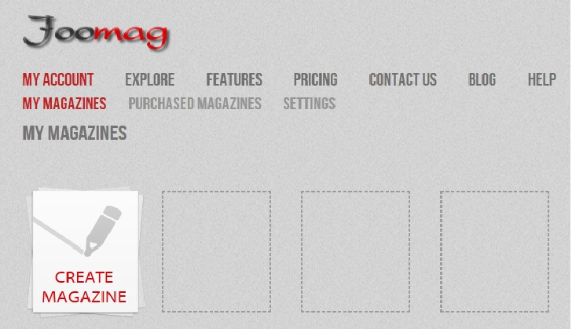

- Complete the next page exactly as follows:
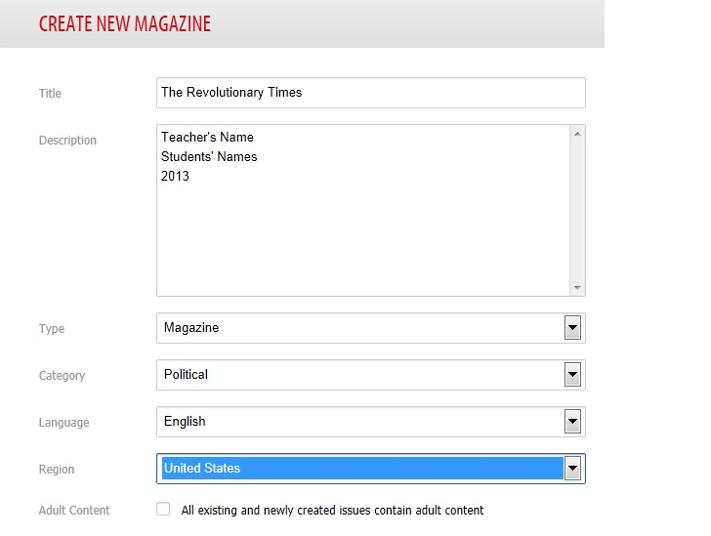
- Click “next” and ignore the “logo” by clicking “Next”
- On the next screen, click “Create From Template”
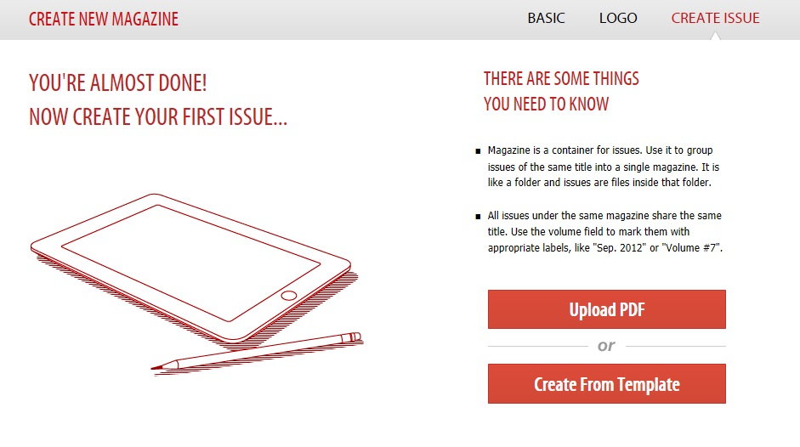
- On the next screen, type in the number of pages you will need (usually this will be 6) and choose the “blank” template before clicking “Next.”
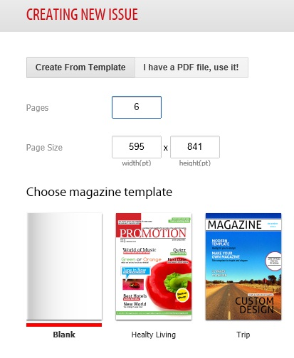
- Fill out the next page as follows, using YOUR Issue Title and description before clicking “Next.” You may choose to “Allow Print” if you choose.
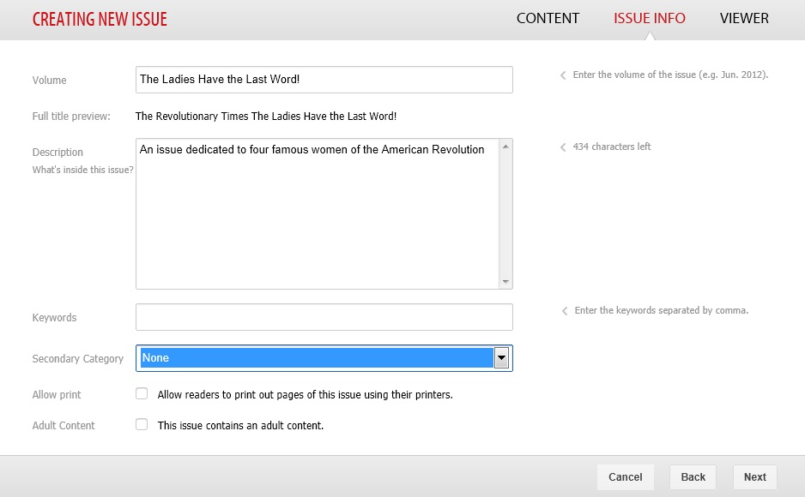
- Choose one of the options as your background. You may not upload your own document as this is an upgrade to the software.
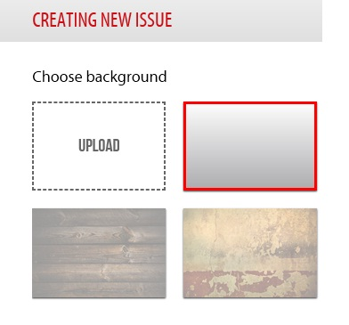
- One more step! Click on “Create New Issue”, then click on the Issue page.
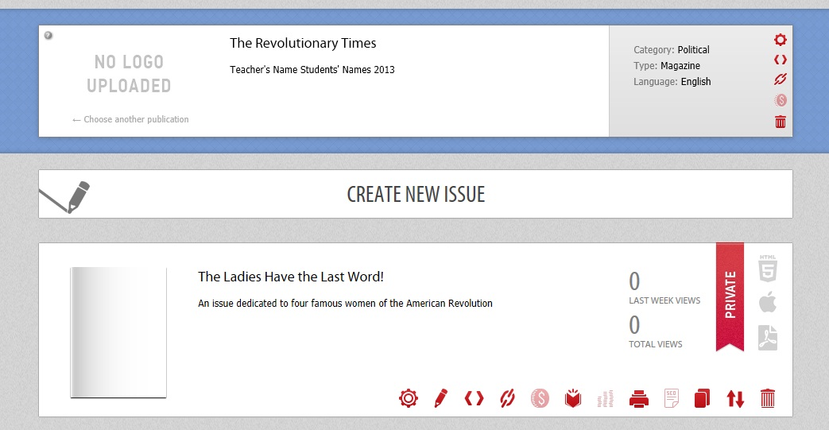

- You are now ready to create your cover. You are doing this using the website “Big Huge Labs.” See separate instructions for creating your cover.
PROJECT REQUIREMENTS:
Each student will have one page in your magazine to complete. Each page must include AT A MINIMUM (that means you can certainly do MORE):
- 1 picture and/or photo gallery (slide show)
- 2 text boxes (one paragraph for each OR a bulleted list including)
  - Interesting or important/key facts
  - Did You Know? (these are little known facts about your topic)
  - Significant contributions (why we remember this topic)
- Choose 2 of the following options
  - Short video (or clip) with your commentary or summary

  - Sound recording (podcast) done by you (use Audacity) [Examples: quote, slogan/saying, brief paragraph or have your idea approved by the teacher]
  - Collage of pictures with explanatory captions
  - 2 external links to “more information about your topic”
  - Timeline (can use an online tool—TimeToast, or create your own)
- At least 3 different research sources (book, websites, magazine articles, database, videos)--Don’t forget to contribute to the group Bibliography on the back cover of your issue!

